Name:- Naipunya Vinod Naik

USN:- 4AL18CS050

Group-6

Topic: Design and implement python code for backing up a folder into a zip file

Output:

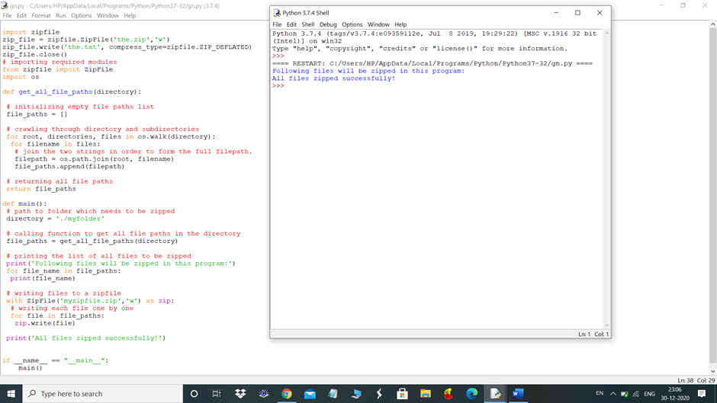

the .zip(the.txt created to zip)

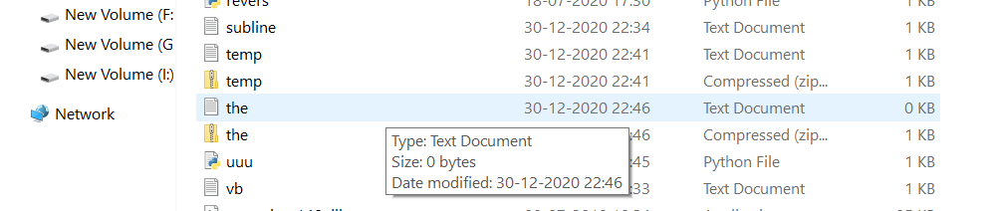

Showing all Paths in python folder:

